**Digital Signal Processing**

**Assignment 01**



Submitted By: **AWAIS SADDIQUI**

Registration No:  **21PWCSE1993**

Section: **“A”**

“On my honor, as student at University of Engineering and

Technology, I have neither given nor received unauthorized.

assistance on this academic work”



**Student Signature: ______________**

Submitted to:

**Dr Ihsan Ul Haq**

**Department of Computer Systems Engineering**

**University of Engineering and Technology, Peshawar.**

**OBJECTIVE:**

The objective of studying exponential sequences lies in their pivotal role in signal analysis and processing. Real exponential sequences are fundamental in modeling signal dynamics, while complex exponentials are essential for frequency domain analysis. This knowledge is used for effective modeling and analysis of signal behavior.

**Task:**

Write MATLAB code to generate output graphs for exponential sequences for Real and Complex Paraments.

Using Equations x[n] = A α^n for Real Graphs. Let A=1.5, n= -10 to 10

**Code:**

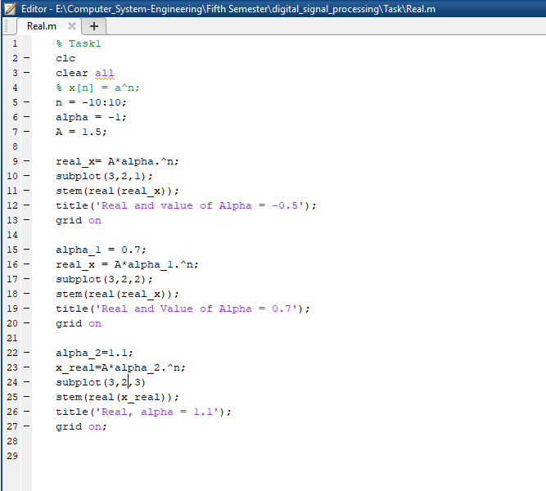

**Output:**

**Code:**

Using Equations x[n]=|A |e j(ω0n+φ) = |A | cos (ω0n + φ) + j |A |sin (ω0n + φ)

for Complex Graphs.

Let A=2, n= -10 to 10



**Output:**

